webprogramming   
lab 14

23BCE1016

## Question 1

## Code

## Output

## Question 2

## Code

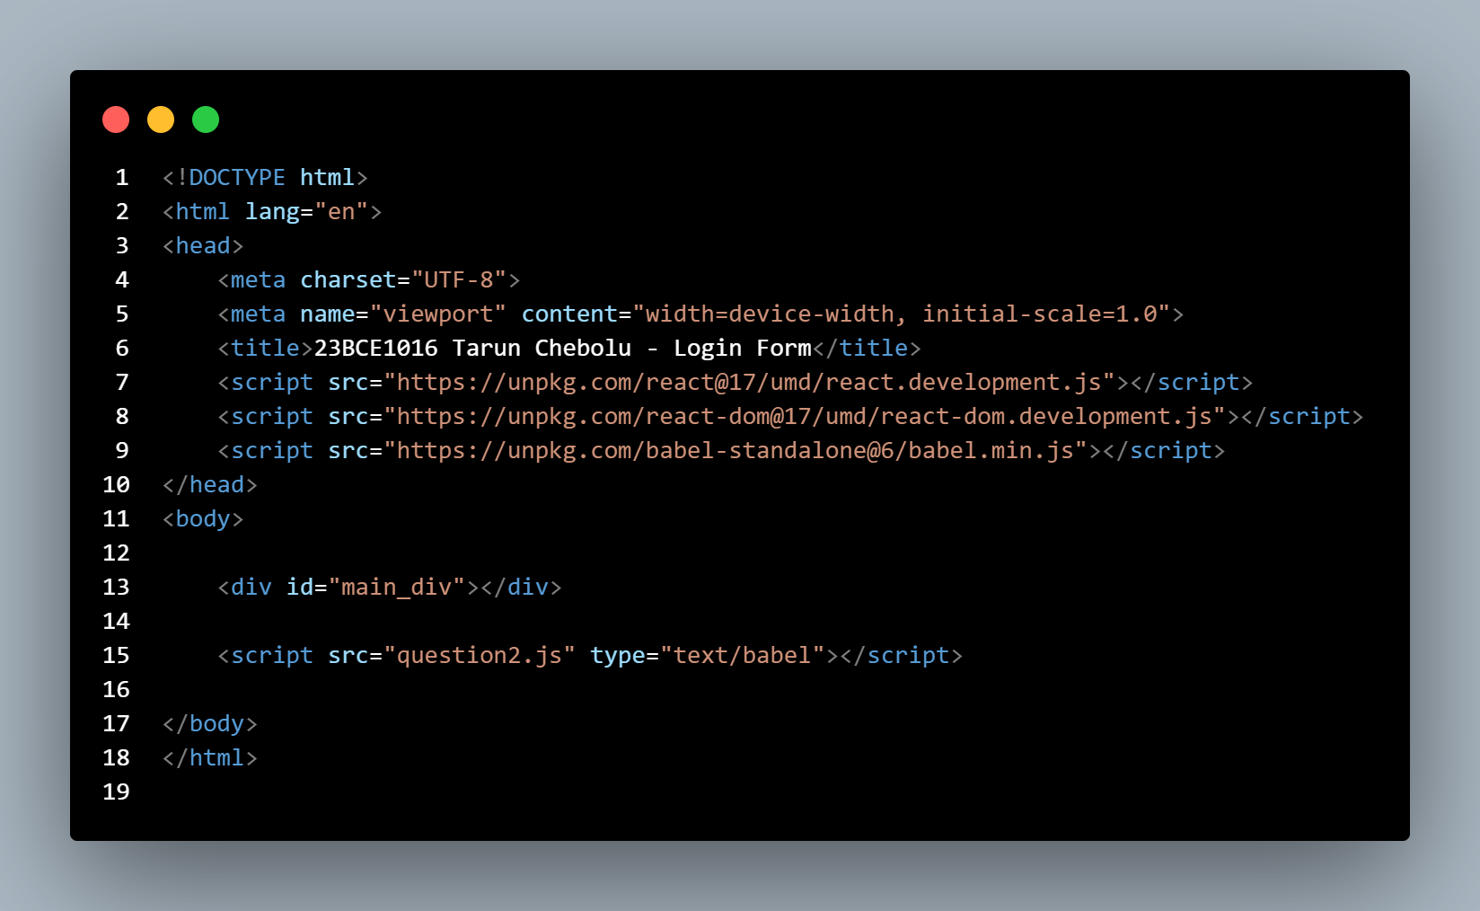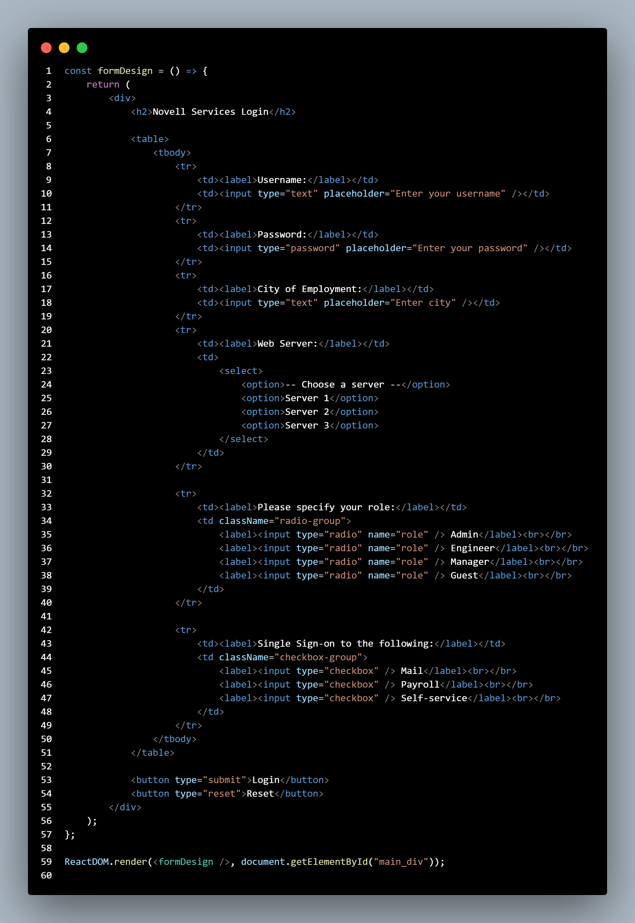

## Output

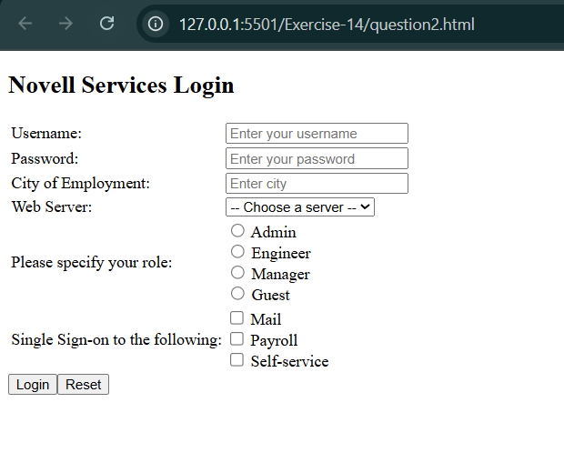

## Question 3

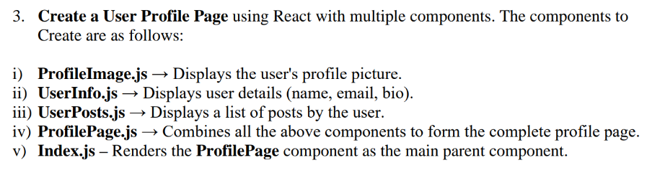

## Code

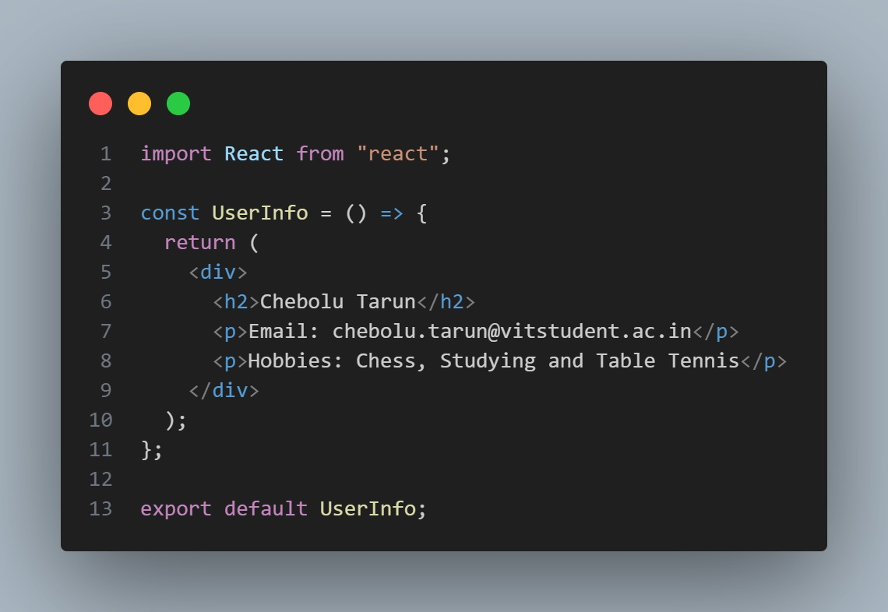

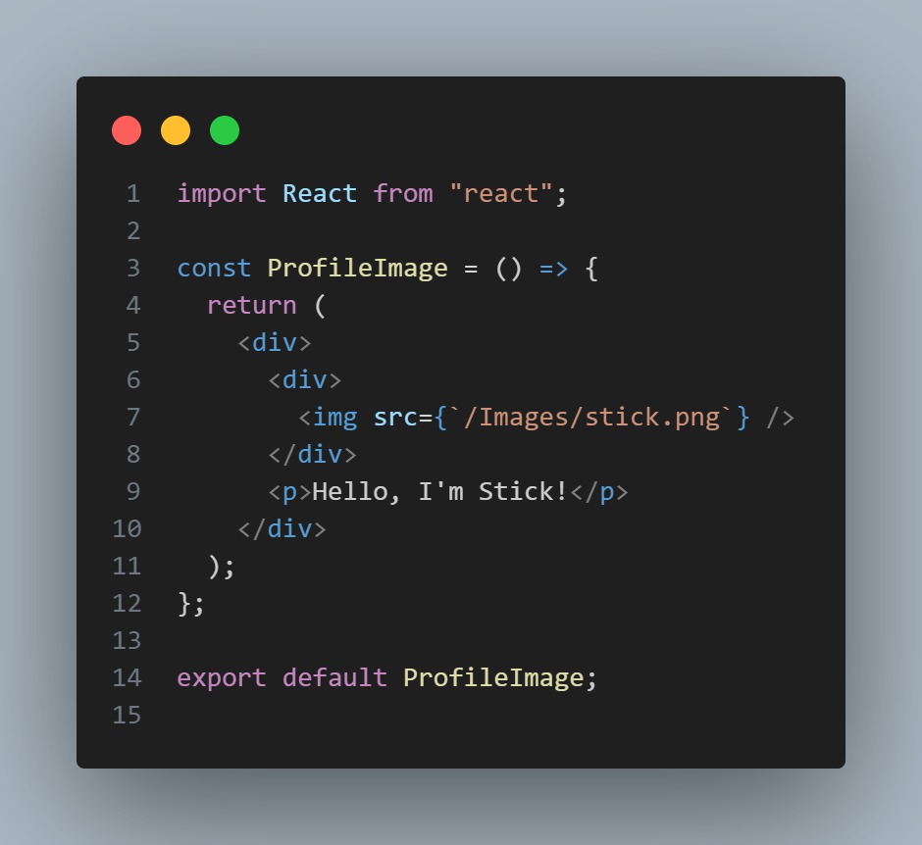

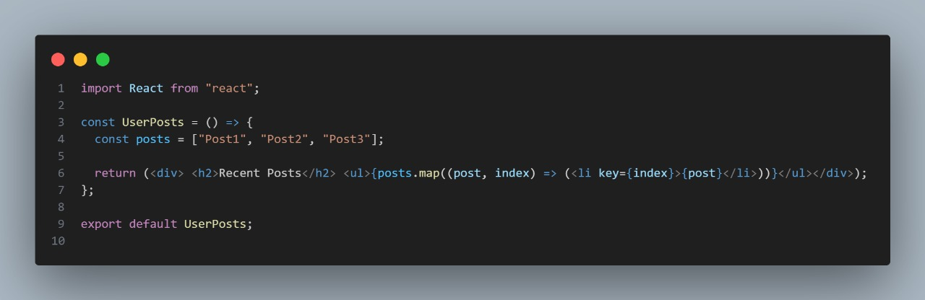

## 

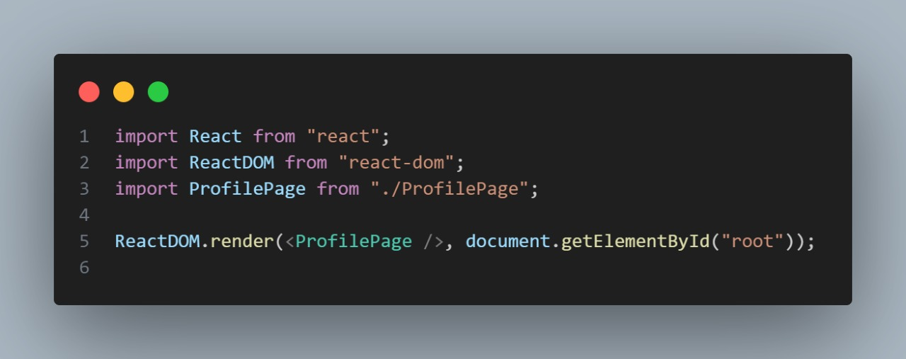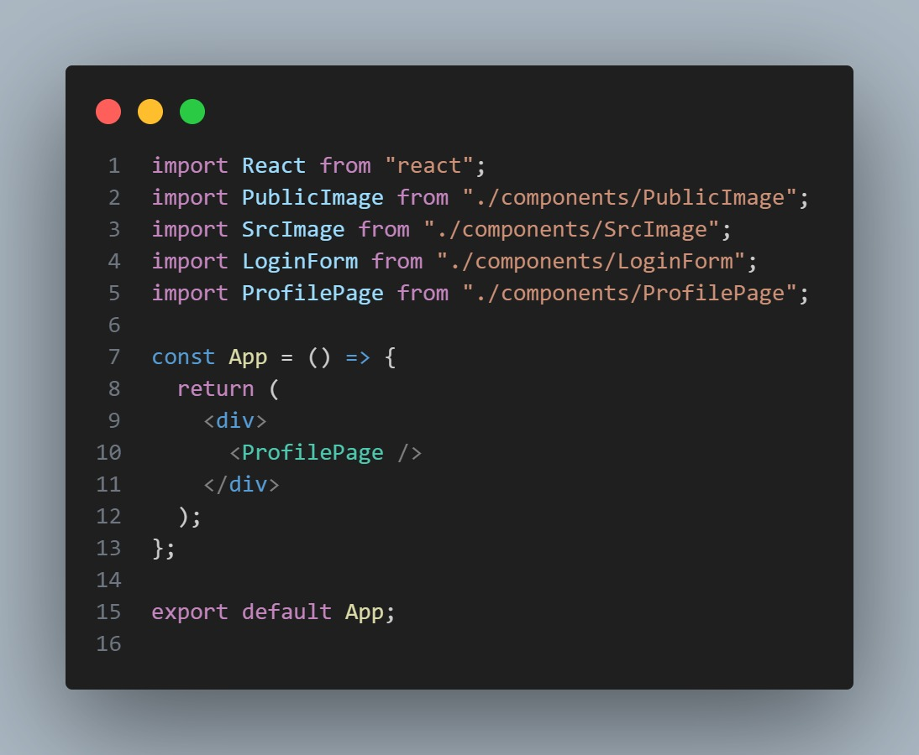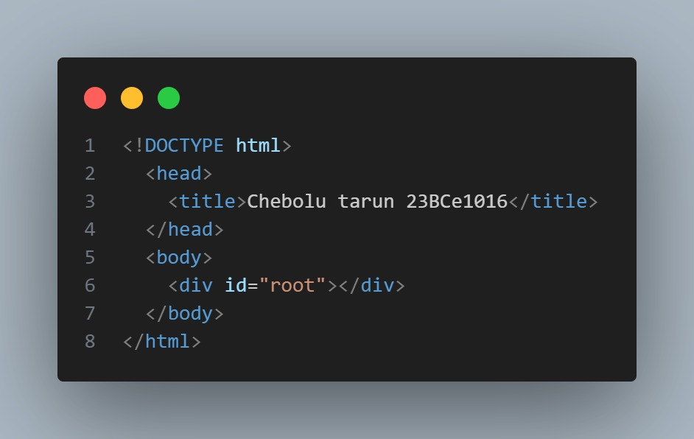

## Output

